HEXAWARE

Coding Challenge

-- Task 1: Initialize the database for PetPals

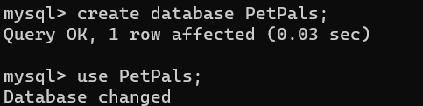

-- Task 2: Create tables for pets, shelters, donations, adoption events, and participants

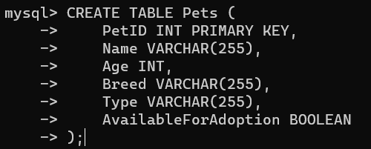

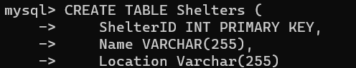

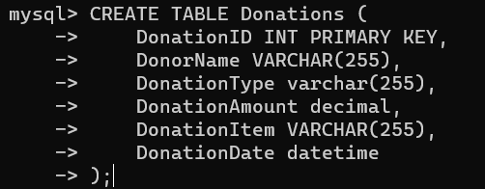

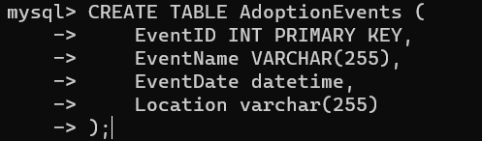);



Task 3: Define appropriate primary keys, foreign keys, and constraints

Constraints can be added during table creation, such as foreign keys and unique constraints.

Task 4: Ensure the script handles potential errors

This is handled by the "IF NOT EXISTS" check for the database and tables.

-- Task 5: Retrieve a list of available pets

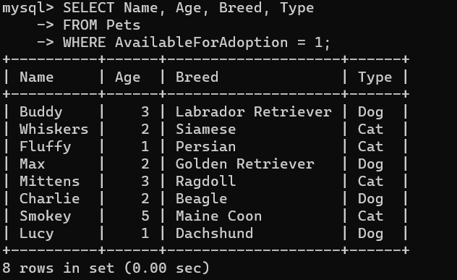

-- Task 6: Retrieve names of participants for a specific adoption event

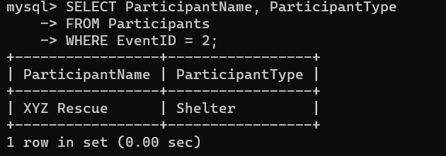

Task 7: Create a stored procedure to update shelter information

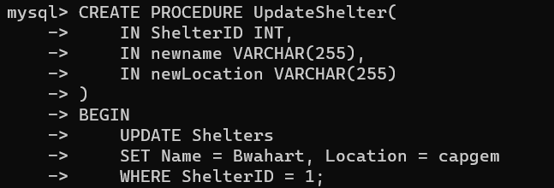

8. Write an SQL query that calculates and retrieves the total donation amount for each shelter (by shelter name) from the "Donations" table. The result should include the shelter name and the total donation amount. Ensure that the query handles cases where a shelter has received no donations.

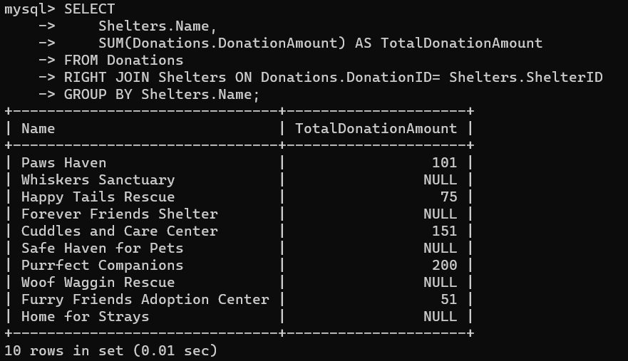

9. Write an SQL query that retrieves the names of pets from the "Pets" table that do not have an owner (i.e., where "OwnerID" is null). Include the pet's name, age, breed, and type in the result set.

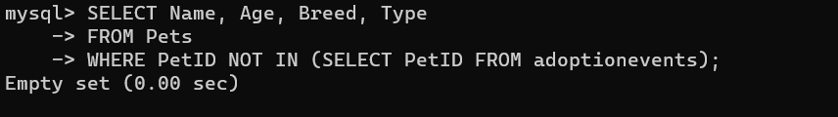 10. Write an SQL query that retrieves the total donation amount for each month and year (e.g.. January 2023) from the "Donations" table. The result should include the month-year and the corresponding total donation amount. Ensure that the query handles cases where no donations were made in a spe

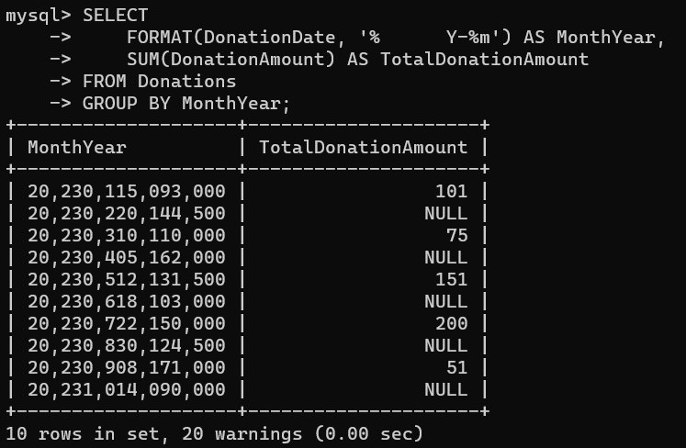

11. Retrieve a list of distinct breeds for all pets that are either aged between 1 and 3 years or older than 5 years.

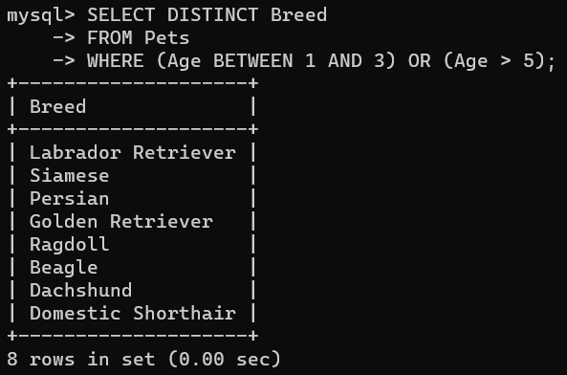

12. Retrieve a list of pets and their respective shelters where the pets are currently available for adoption.

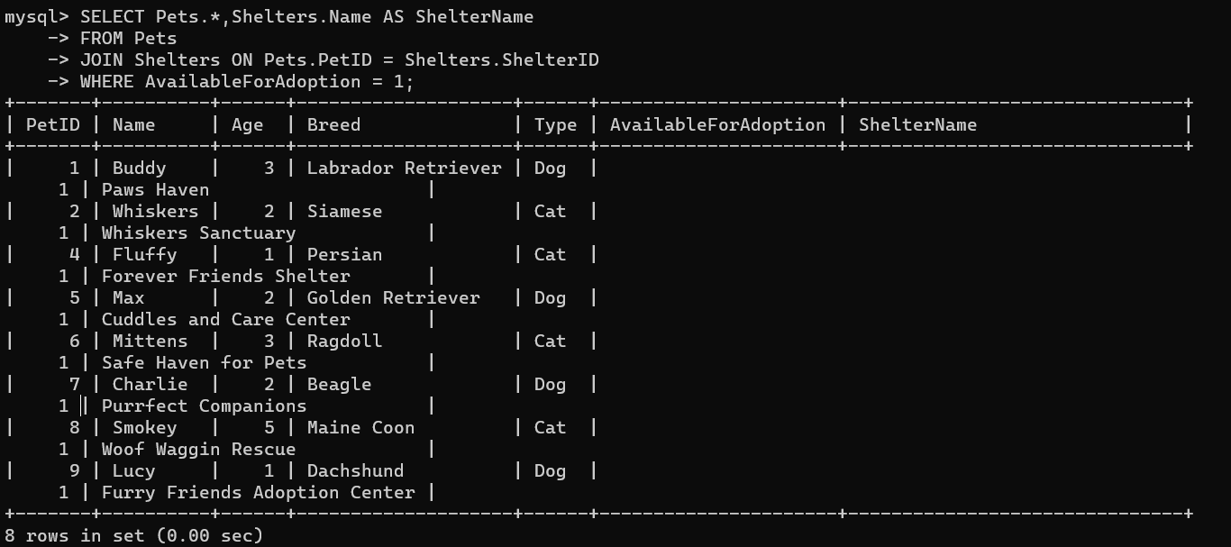 13. Find the total number of participants in events organized by shelters located in specific city. Example: City=Chennai

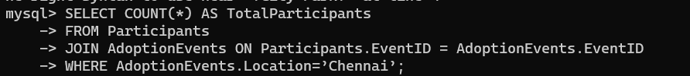

14. Retrieve a list of unique breeds for pets with ages between 1 and 5 years.

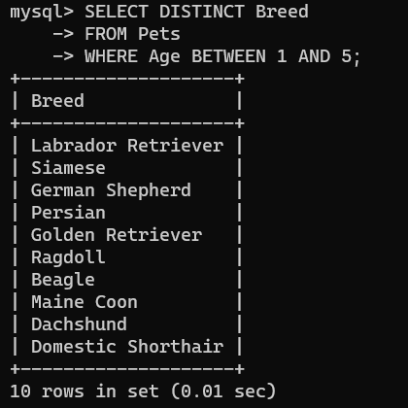

15. Find the pets that have not been adopted by selecting their information from the 'Pet' table.



16. Retrieve the names of all adopted pets along with the adopter's name from the 'Adoption' and 'User' tables.

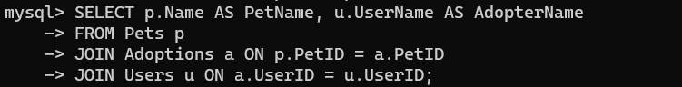

17. Retrieve a list of all shelters along with the count of pets currently available for adoption in each shelter.

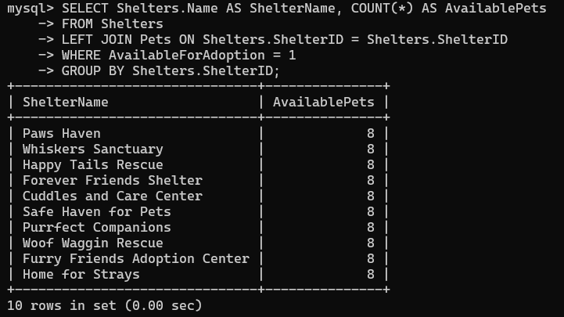

18. Find pairs of pets from the same shelter that have the same breed.



19. List all possible combinations of shelters and adoption events.

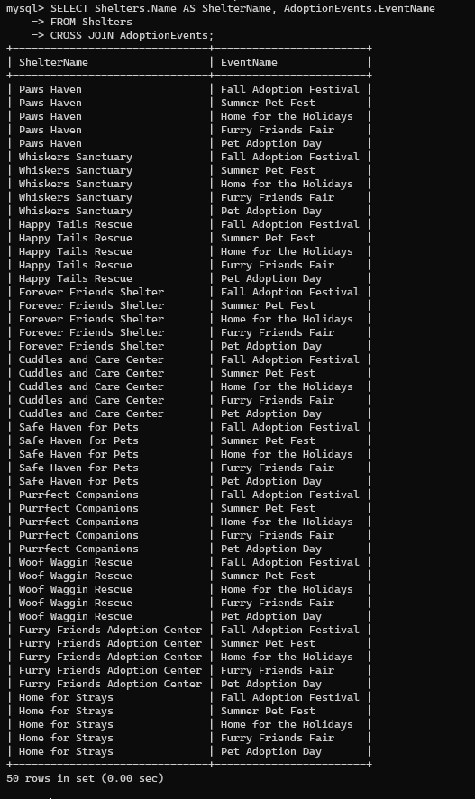

20. Determine the shelter that has the highest number of adopted pets

